H. Dip Science in Computing, National College of Ireland, Submitted 7/12/18

Web Design report

<https://glacial-castle-40173.herokuapp.com/>

Johnathan Munster

Kevin Kerin

Sebastian Ryan

**Overview**

Our objective is to create a simplistic, intuitive, and visually appealing website that responds to the need for cheaper, faster, and simpler hiring of cars. Whilst we recognise the car hire market is indeed a saturated one, however we also believe we have something different, something better. We are passionate about giving consumers choice and giving consumers flexibility. Our mission, should we succeed, will be a website for all; owners and renters. If you have a car you are not using, even for a day, why not profit from this? If you need to hire a car, or need a van for just one day, we have you covered. And, if you need a car for just a few hours? Nowhere else will give you that flexibility.

**Design**

**Research**

If we ever wanted to take this website further, we needed to explore the possibility of direct competitors in the market. As a group we wanted to be different. We wanted to stand out. This is not just a website for a group submission; this a website we can take further should we wish to. We needed to familiarise ourselves with our competition and we needed to understand what the legal framework for such an industry is. As noted above, this is indeed a saturated market, with household names such as [Enterprise](https://www.enterprise.ie/en/home.html), [Budget](https://www.budget.ie/), and [Europcar](https://www.europcar.ie/) to name but a few, but we can offer something new; a niche in the market as we know it. We also recognise additional challenges from sites such as [Kayak](https://www.kayak.ie/cars/) and [Expedia](https://www.expedia.ie/car-hire/) who allow users to do everything in one go – book flights, hotels, and hire cars. And whilst we will not limit ourselves to any narrow market, this is not the market we wish to initially target. It must be noted there is already a competitor in the traditional sense of the word, but [Fleet](https://www.jointhefleet.com/) have had a low user uptake and poor advertising of their business. Furthermore, they do not give you the option to hire for a partial day.

Finally, it is not about who is first to market, it is about the site that does it the best. We are confident this will be us.

### Project Development

From the outset, we all had a clear idea how we wanted our site to look, and wireframing was completed at a very early juncture. We needed a clear and streamlined functional integration of our conceptual design whilst carefully balancing what little skillset we possessed. Our ambition was great; our time was short.

Our concept was to be a simple one with the ambition of employing a minimalistic site being our end goal. It should be intuitive and friendly. Delegating was quickly agreed, however we all sought advice from each other and all tested each other’s work.

**Roles**

Whilst we all contributed and looked at each other’s work for this was a unified group project, the main tasks delegated from the outset were:

Main page: Johnathan Munster

About: Sebastian Ryan

Contact: Sebastian Ryan

Bootstrap: Johnathan Munster

Login: Johnathan Munster

Signup: Johnathan Munster

Database: Johnathan Munster

Ad development: Kevin Kerin

Calendar: Kevin Kerin

CSS review: Johnathan Munster, Kevin Kerin

Google Maps API: Kevin Kerin

Hosting: Johnathan Munster

Front end review: Johnathan Munster

Back end review: Kevin Kerin

Project Report: Sebastian Ryan

Final editing: Johnathan Munster, Kevin Kerin

**Wireframing**

Wireframing was keenly implemented and ideas shared in the first seek, and by the end of week we had a very clear idea of how we wanted our site to look and how we wanted it to feel. We needed a clear and streamlined functional integration of our conceptual design whilst carefully balancing what little skillset we possessed. Our ambition was great; our time was short.

Our concept was to be a simple one with the ambition of employing a minimalistic site being our end goal. It should be intuitive and friendly. Delegating was quickly agreed, however we all sought advice from each other and all tested each other’s work.

A selection of images showing our wireframing can be seen below:

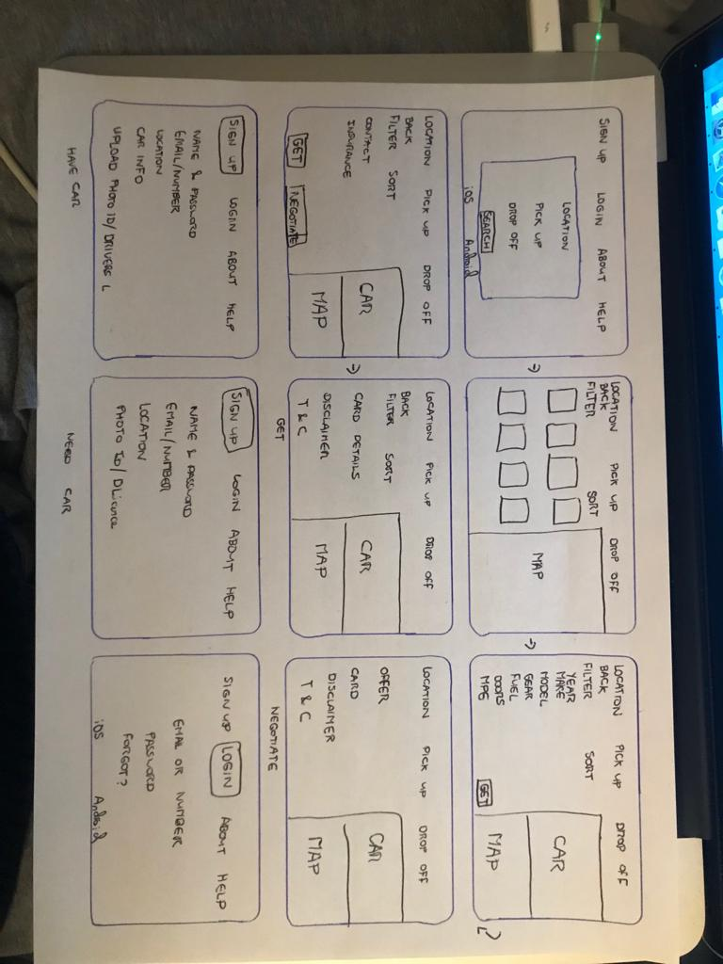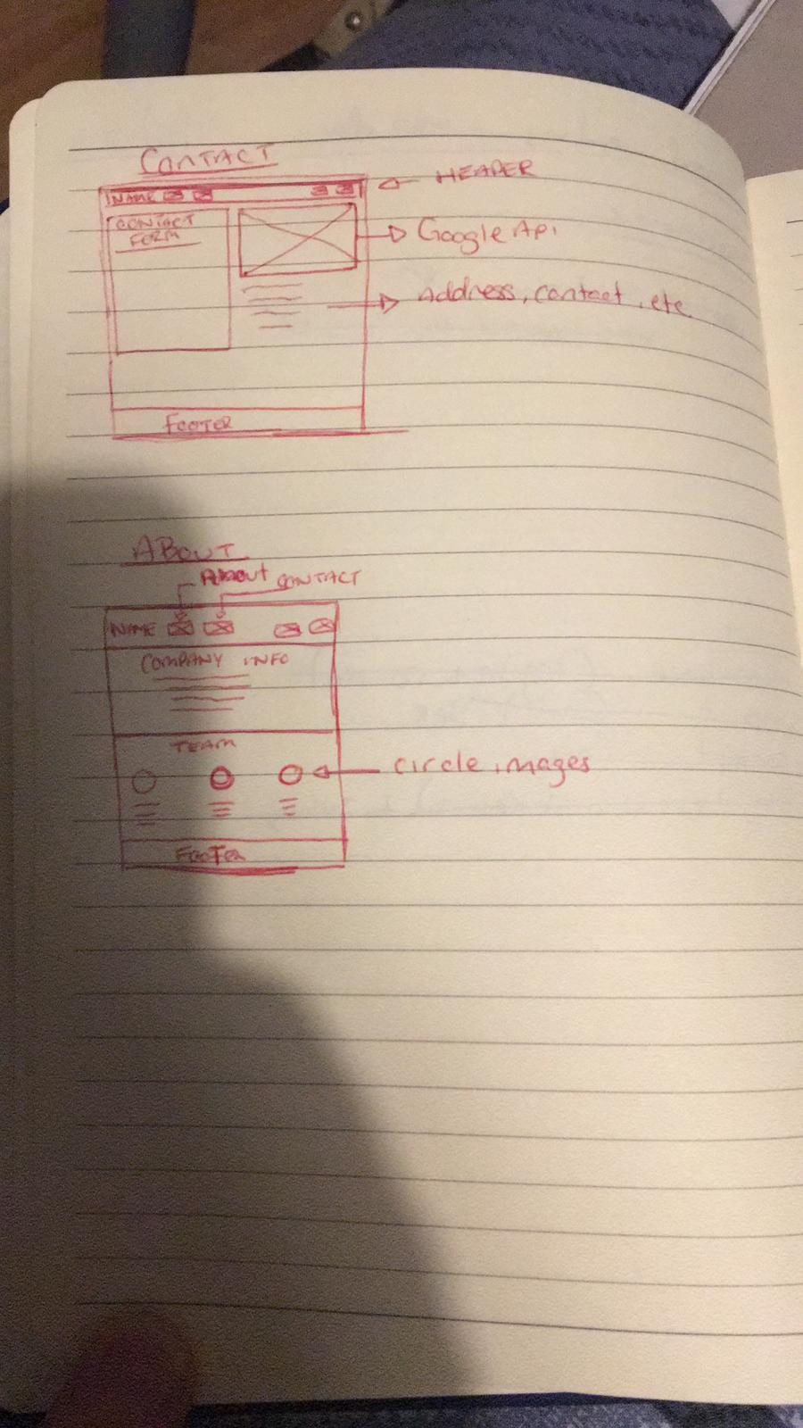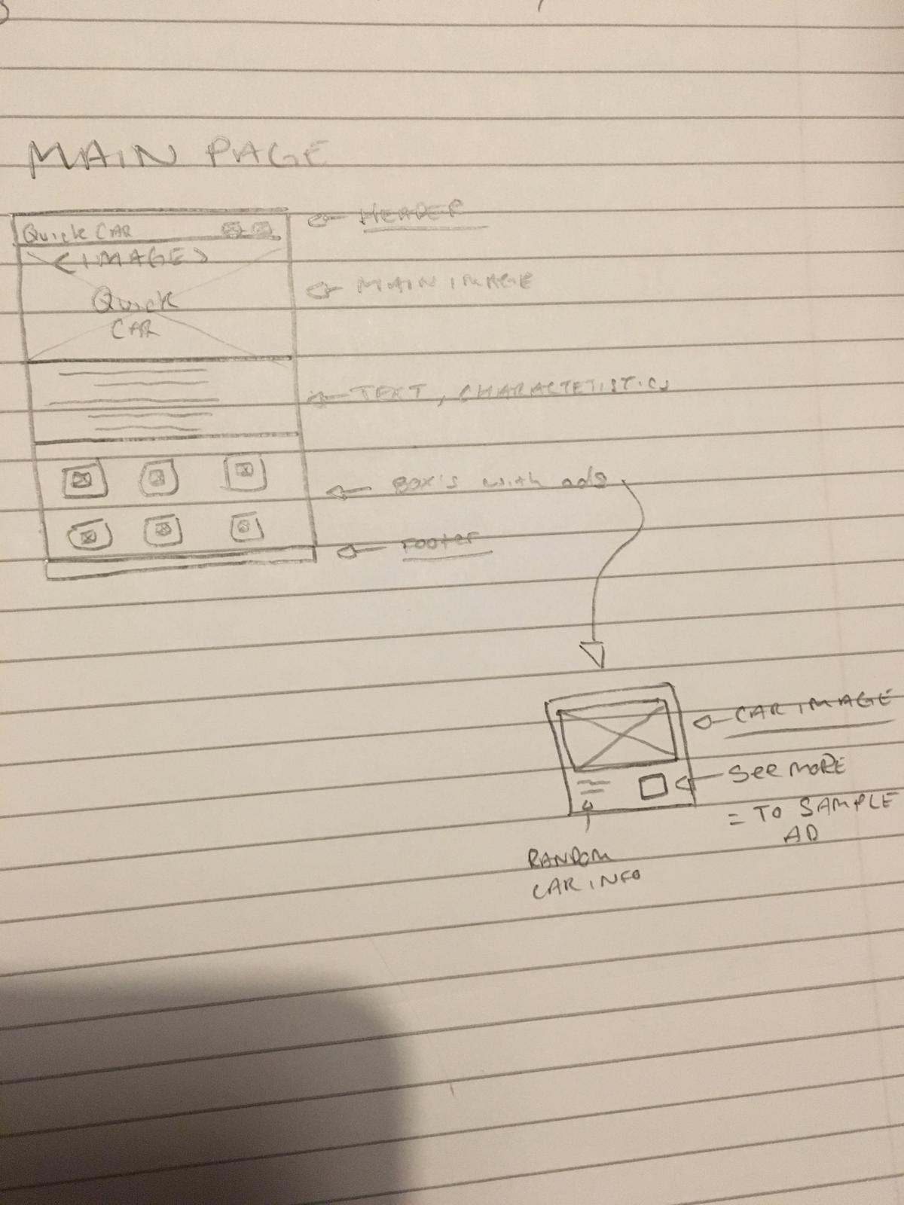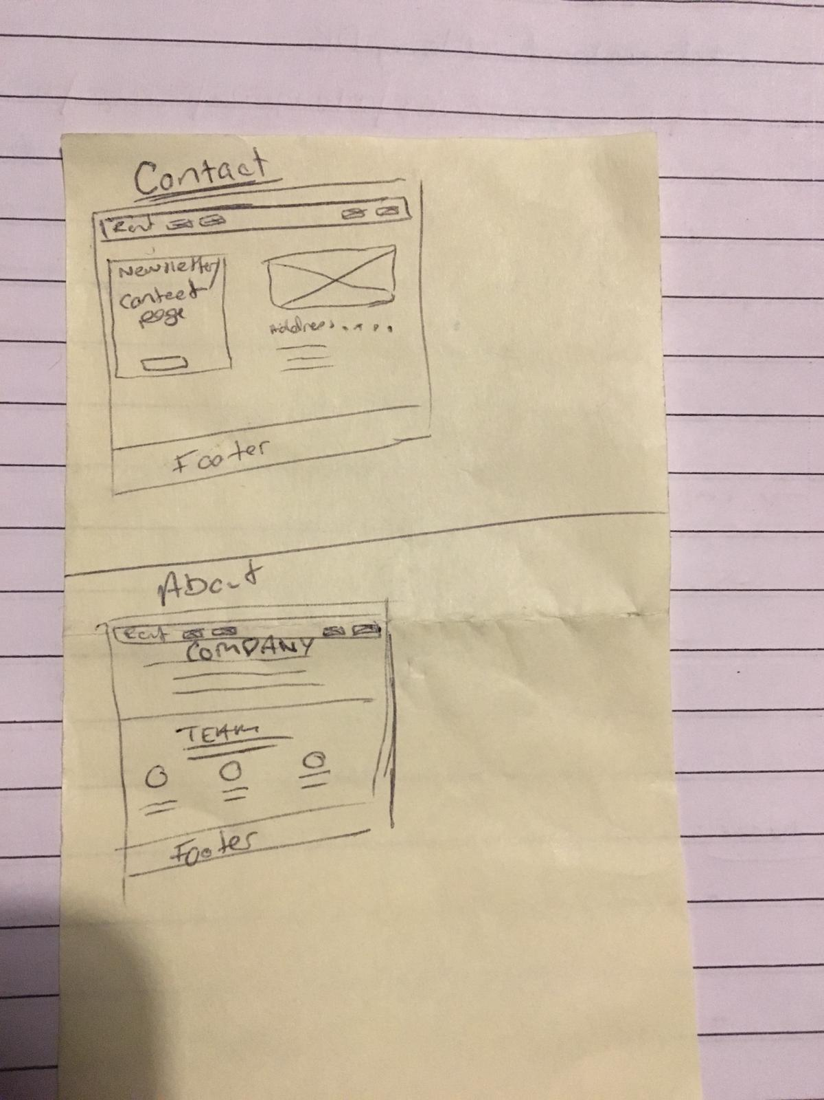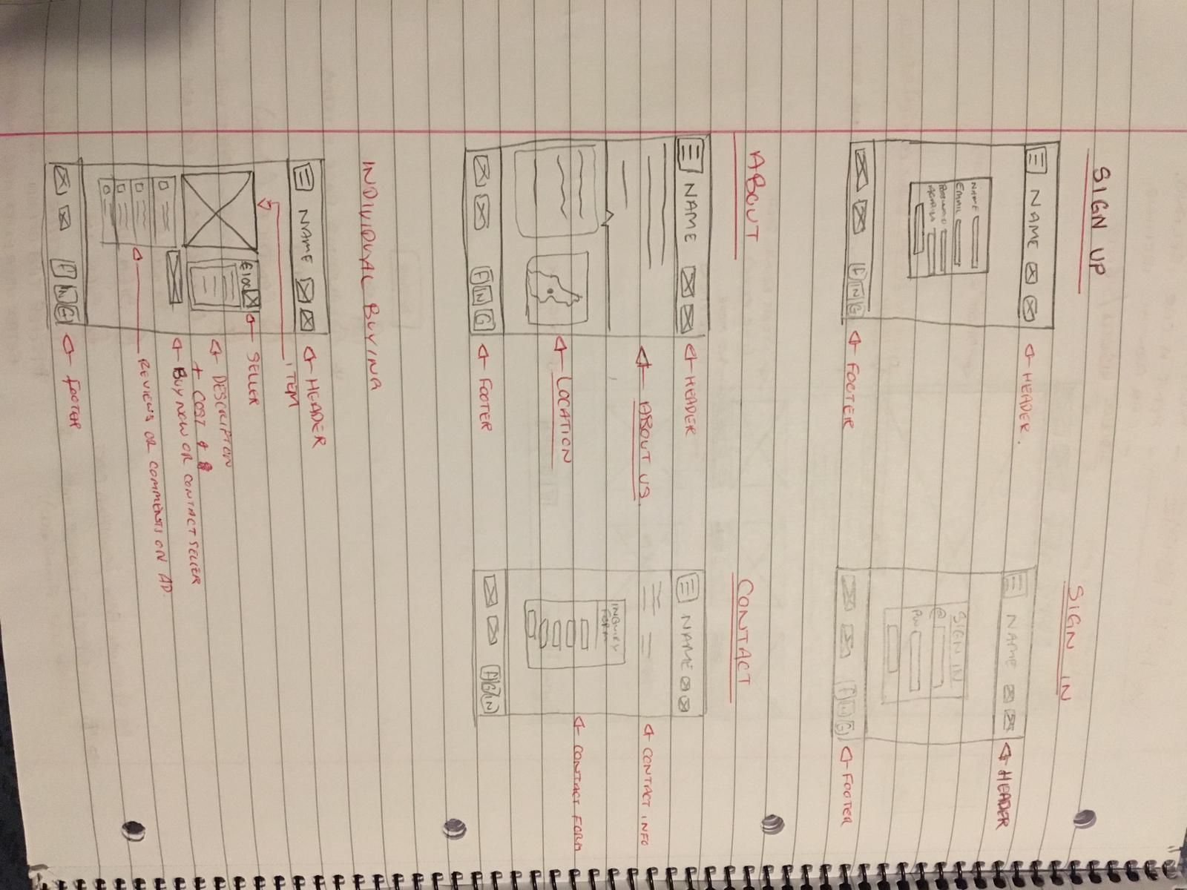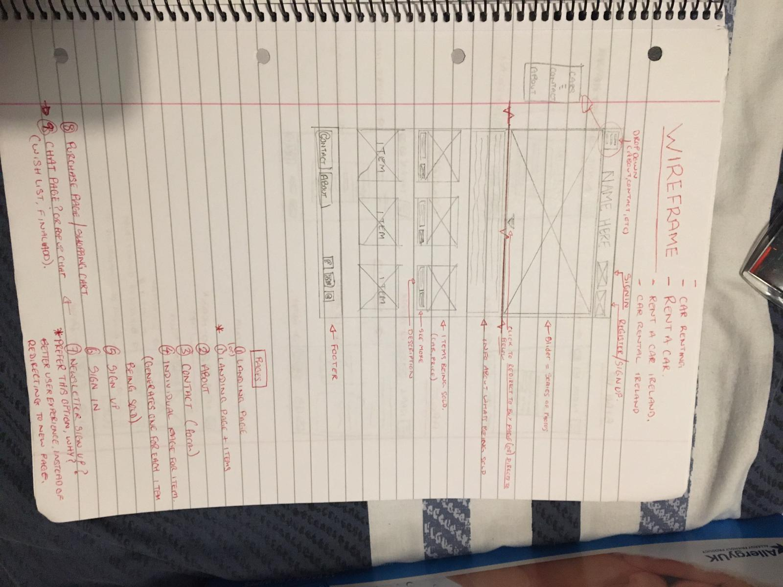

**Development**

**Validation & Errors**

Our landing page presented a few errors due to incorrect anchor tag formatting, directory saving, and some CSS editing. Upon noticing and correcting these issues, our landing page did not present any error after validation. We wanted our background image to be fixed to fit any screen to keep it responsive but instead of this expectation, the image stayed still in the background and moved with the screen. Simple coding research allowed us to resolve this issue.

It was a similar story on both our Contact and About pages, where our CSS needed attention so formatting was pleasant on the eye, for e.g. Borders, unity, consistent formatting.

Kevin Kerin did a superb job on the ad page for our site, with a phenomenal eye for detail allowing Kevin after hours of research to push a legible, flowing, and detailed version to Heroku.

Finally, both the SignUp and SignIn pages continue to present similar errors – we are unable to get error messages to show, and indeed at the opposite end of the spectrum, we are unable to get successful validation messages to show on screen for the user as well.

**Deployment**

As Johnathan Munster had prior experience hosting to [Heroku](https://www.heroku.com/), it was immediately agreed to use this platform over others to host and test our site for errors. As a team we would push the code to Johnathan, and he would deploy and report back on errors. Multiple browsers were tested as well, however Safari was avoided due to its security preferences.

URL: <https://glacial-castle-40173.herokuapp.com/>

**Screenshots of the Site**

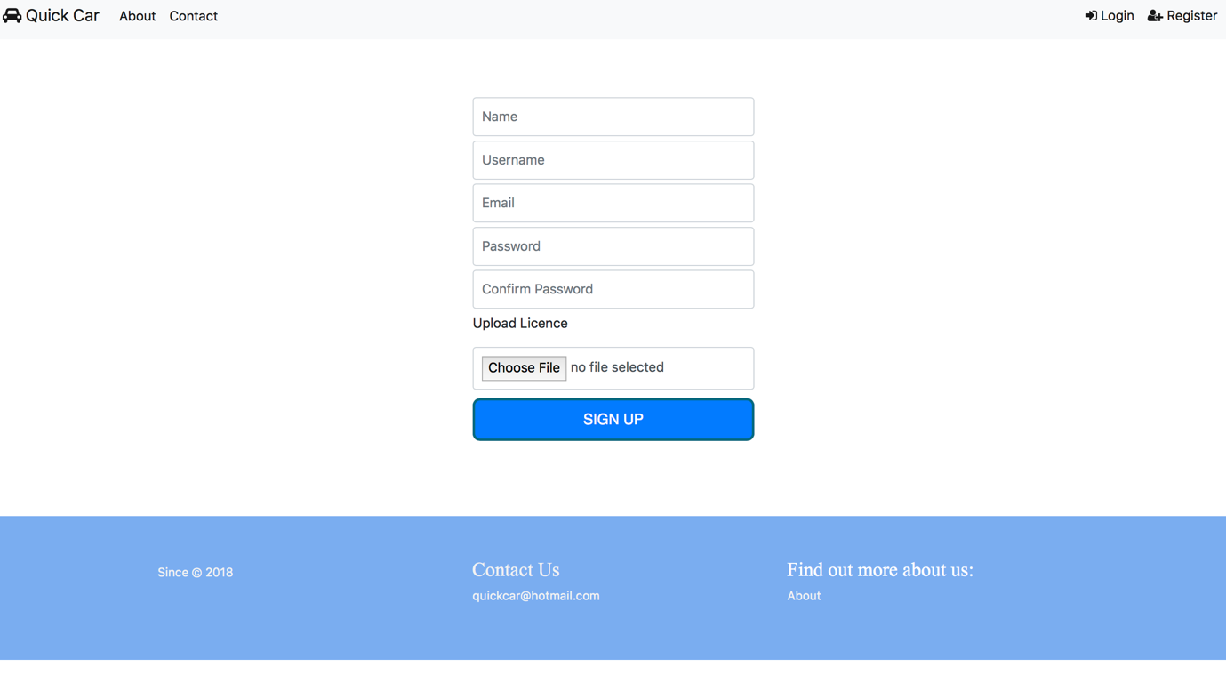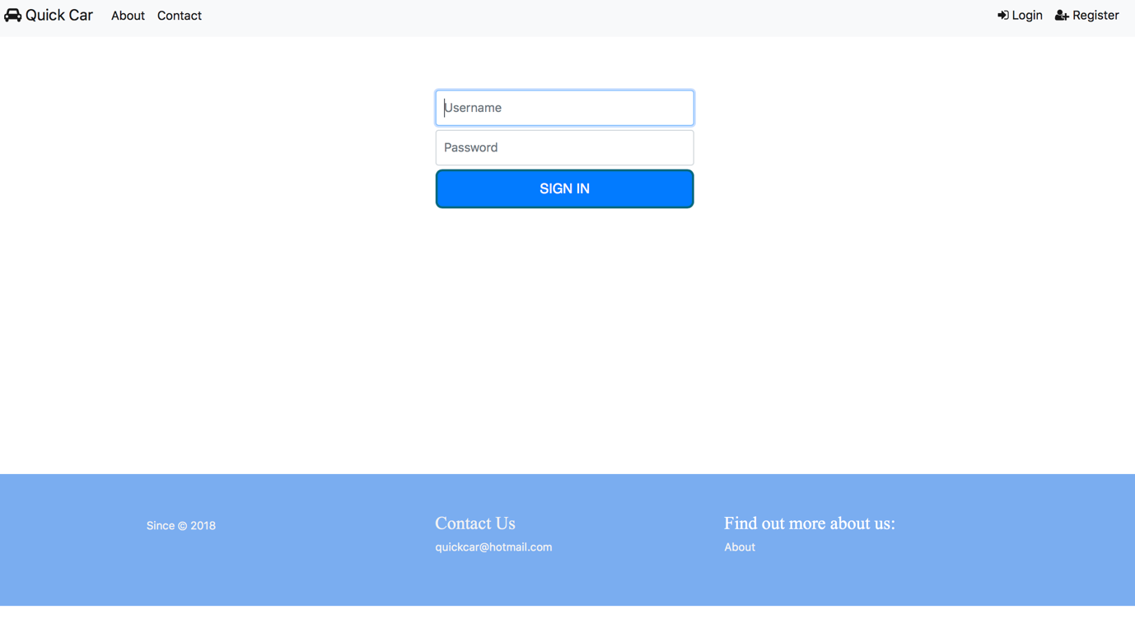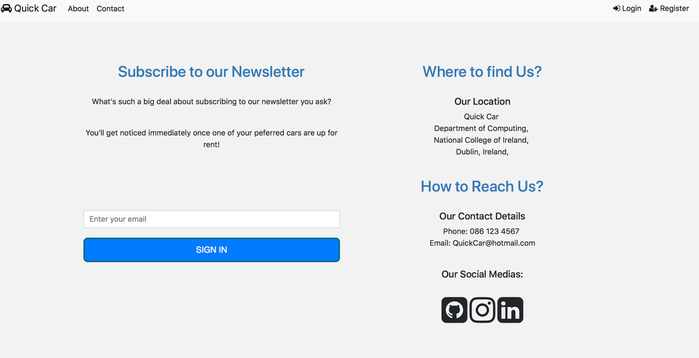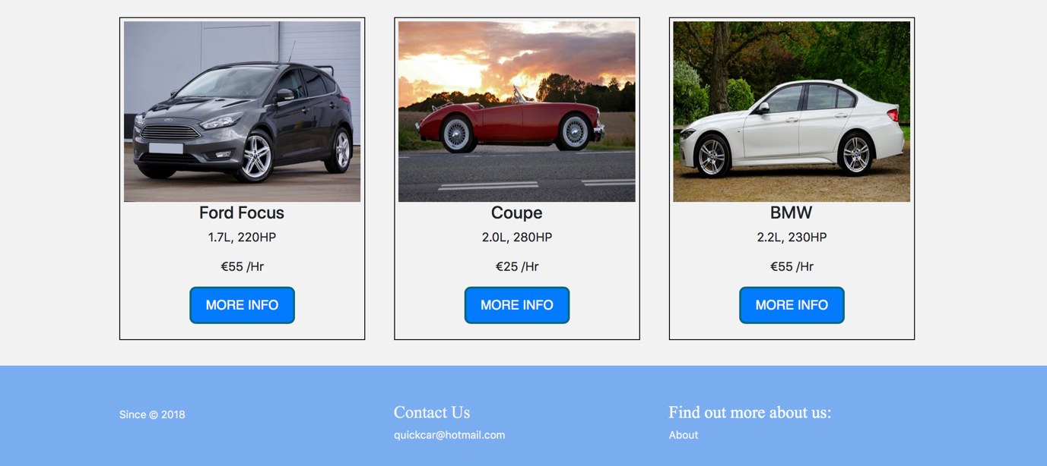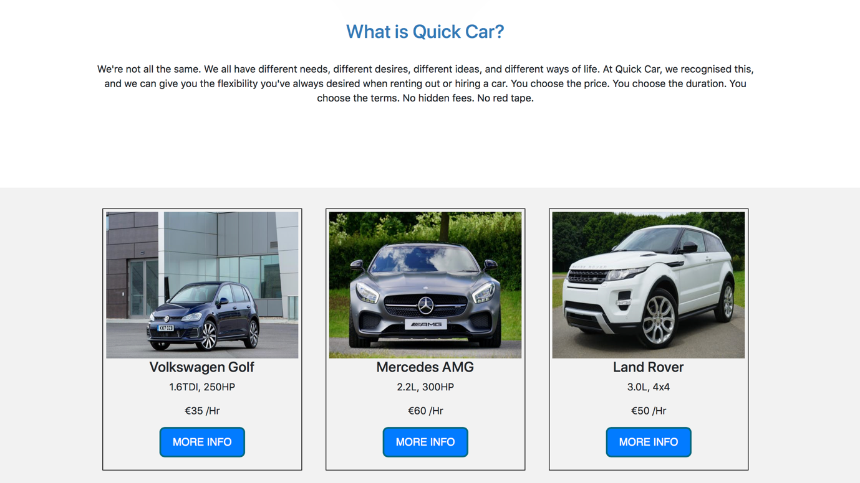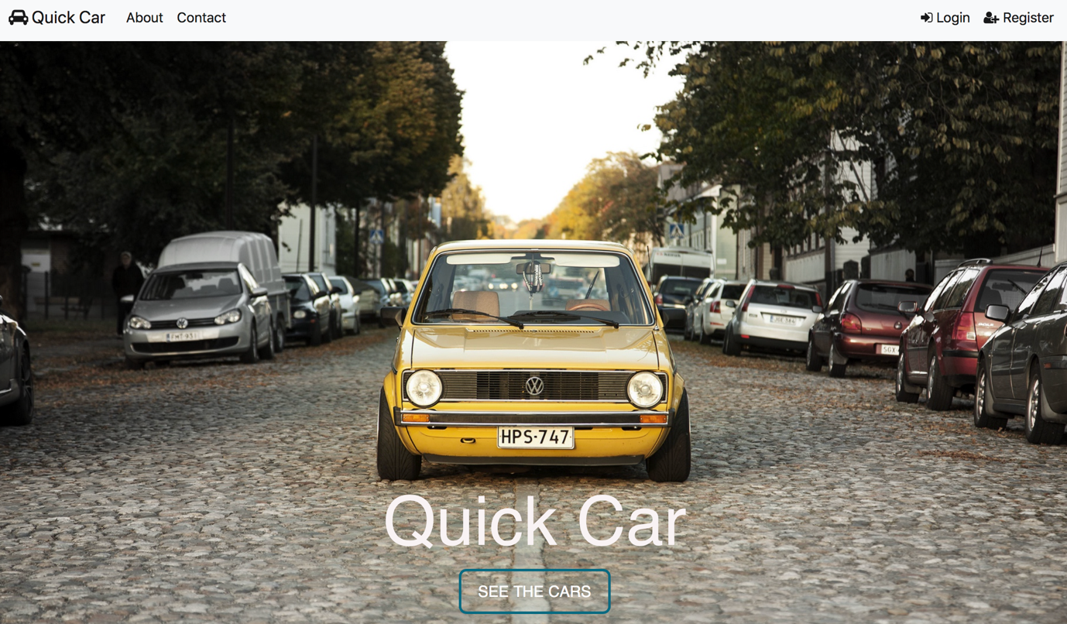

**Conclusion**

Whilst hindsight is a very valuable gift, we all recognise that we simply did not have the time was believed we had. We all work full time jobs in different backgrounds and industries, and we work long hours. Finding the time to meet together and discuss the project at length was indeed a challenge for all of us. Furthermore, we all recognise we have different skillsets, and embracing this rather than challenging this was a skill we needed to learn. This project was a worthy replication of a real world scenario, and it was a terrific experience to complete.

Whilst we wish for more time, and we are driven to produce our best work, we recognise we have produced something we did not deem ourselves capable of 6 months ago. We should be proud and reflect on what we have achieved. With that, we must also recognise our ambition to produce something better next time.

**Personal Reflection**

**Johnathan Munster:**

Kevin, Sebastian and I worked great for our Web Development project. We always kept in regular contact with one another and tried to hold weekly meetings but as we all work and consider personal lives, we might have gotten more meetings in but we also had WhatsApp to communicate with. We gathered our ideas early on and came to a decision after discussing the positives and negatives of each idea. We delegated the workload amongst the team and ensured to keep update with our objectives. We decided to go with a car rental idea which is the end we called it ‘Quick Car’.

All through the project, we came across decisions such as styling, wireframing, the use of tools, etc. We always all came to the meeting with an idea each, so we could have option to discuss and choose from.

If the team ever came across an issue, they couldn’t figure it out, we would try to solve the issue together as some of us had different strengths and weaknesses and by solving it together we learned off one another.

**Kevin Kerin:**

Johnathan, Sebastian and I got on very well throughout the project. Despite the limitations of only being able to contact through Skype and WhatsApp, we managed to communicate well throughout. We delegated our jobs equally and kept in regular contact with regard to updates etc. Originally we had arranged to meet on a close to weekly basis on Skype, with Friday evenings being the preferred time. However, work and life got in the way of these meetings so we did not get to make group calls as often as we’d have liked.

When coming up with ideas for our project, we had some suggestions from each person and eventually decided on the car rental idea. This process was informed and well communicated to each other.

Throughout the planning process, each team member made their own wireframe. We discussed these over Skype and critiqued each other constructively and eventually came up with the best designs for each page.

During the development process, we all managed to keep each other updated through WhatsApp. I felt that I was always informed with the other members’ progress, and if we hit any ‘walls’ we had each other to ask questions etc. Again, I felt this worked very well. We all brought different strengths to the group and I feel that we used our strengths to our advantage.

In the deployment stage, Johnathan did a great job in setting up Heroku to deploy the website. I deployed my own page through another web hosting service, however we as a group decided on Heroku for the deployment of the full page as it seemed easier to navigate and was more well known within our group.

**Sebastian Ryan:**

I immensely enjoyed working with my colleagues, and I can confidently say they are better programmers than I am, and they are better at testing code than I am. It was a valuable experience working alongside such rounded budding developers, and one that I shall learn from. The quality of the work submitted is in large thanks to Johnathan and Kevin’s knowledge, skill, and input.

As a team we worked well, but it must be noted that we would have wished for more free time to work together, as our lives simply restricted us doing so. WhatsApp and Skype were saving graces for us, and the majority of our communication utilised these two media.

Our initial wireframing was clear, and we instantly had a rapport and motivation to produce something special; something we could be proud of. Communication lines were always open, and nobody was ever afraid to ask for help, ask for an explanation, or to point out an error. I believe we kept each other updated regularly and clearly.